Homework Set #6
CSCE2114 – Digital Design
Spring 2017
Due: Monday, April 24, 2017
45 Points

1) (5 points) Implement F(A, B, C) = A’C’ + AB’ using an 8-to-1 MUX and any other basic logic gates necessary (AND, OR, NAND, NOR, or NOT gates). Minimize any combinational logic (other than the MUX) in sum-of-products form. Use the left most input(s) for the MUX select input(s).

2) (10 points) Implement F(A, B, C) = A’C’ + AB using a 4-to-1 MUX and any other basic logic gates necessary (AND, OR, NAND, NOR, or NOT gates). Minimize any combinational logic (other than the MUX) in sum-of-products form. Use the left most input(s) for the MUX select input(s).

3) (10 points) Implement F(A, B, C) = (A’+B’)(A+C’) using a 2-to-1 mux and any other basic logic gates necessary (AND, OR, NAND, NOR, or NOT gates). Minimize any combinational logic (other than the MUX) in sum-of-products form. Use the left most input(s) for the MUX select input(s).

4) (15 points) Implement F(A, B, C) = (A’ + B’)(A’ + B + C’)(A + B + C’) using a 2-to-1 mux and any other basic logic gates necessary (AND, OR, NAND, NOR, or NOT gates). Minimize any combinational logic (other than the MUX) in sum-of-products form. Use the left most input(s) for the MUX select input(s).

5) (5 points) Implement F(A, B, C)= (A + B’ + C)(A’ + B)(A’ + C’) using only a 3-to-8 decoder and any other basic logic gates necessary (AND, OR, NAND, NOR, or NOT gates). Minimize any combinational logic (other than the decoder) in sum-of-products form. The symbol and truth table for a 3-to-8 decoder are shown below.

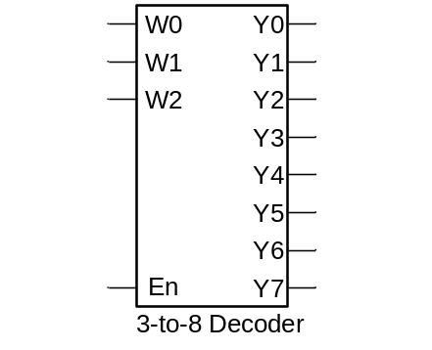En w2 w1 w0 | y0 y1 y2 y3 y4 y5 y6 y7
1 0 0 0 | 1 0 0 0 0 0 0 0
1 0 0 1 | 0 1 0 0 0 0 0 0
1 0 1 0 | 0 0 1 0 0 0 0 0
1 0 1 1 | 0 0 0 1 0 0 0 0
1 1 0 0 | 0 0 0 0 1 0 0 0
1 1 0 1 | 0 0 0 0 0 1 0 0
1 1 1 0 | 0 0 0 0 0 0 1 0
1 1 1 1 | 0 0 0 0 0 0 0 1
0 x x x | 0 0 0 0 0 0 0 0

Symbol Truth Table

